Dear Anna,

**If there was one good thing that resulted from science team, it was meeting you. You have been such a great friend to me for the past three years and I really appreciate it. Thank you for putting up with all my science team rants and my school diatribes. I’ll definitely miss touring high schools with you during WSSLs and I’m definitely going to keep that tradition going for the both of us (they may see miscellaneous sticky notes lining their school walls ;) ).**

**I can’t believe that you’re done with high school… Ahhhhh you’re in college now!! Anna you’re so grown up! I’m going to miss seeing you in the hallways, at lunch, and after school.**

**You’re so smart, kind, and talented (especially with the piano) and you’re going to do amazing things at WPI :) .**

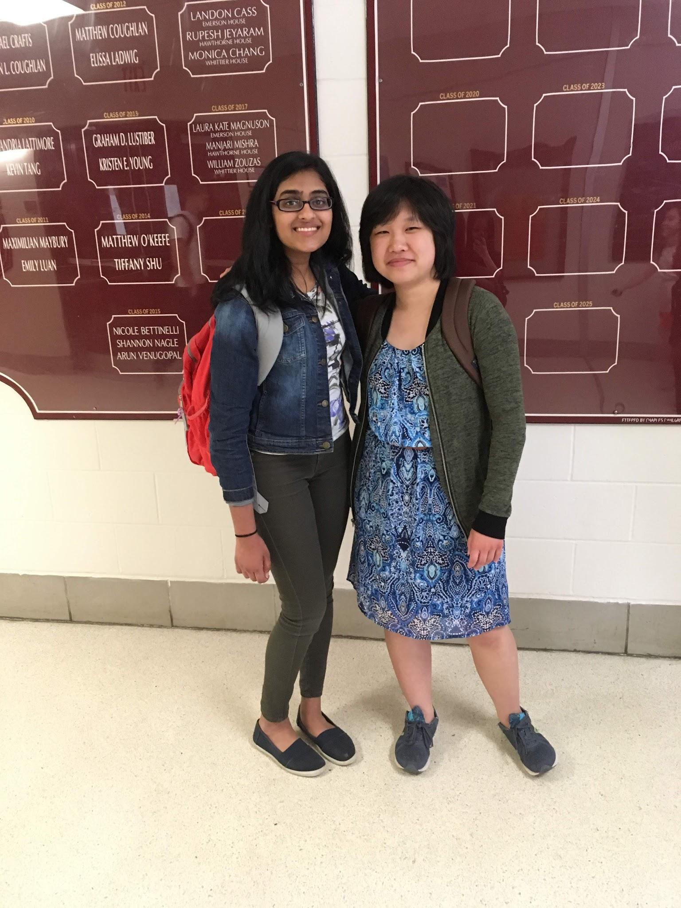

With Love,

Ananya